


T H E W A R D O F C H E A P C L U B
FOUNDED IN 1863

The Ward of Cheap Club and the Cheapside Business Alliance
Invitation to a Business Breakfast

We have pleasure in inviting you to a business breakfast on Wednesday
1 March 2023 at 7.45 am to 9.30 am at Saddlers’ Hall, 40 Gutter Lane, London EC2V 6BR.

The use of Saddlers’ Hall is solely by kind permission of the Prime Warden and the Court of the Saddlers’ Company.

The speaker will be Richard Burge, Chief Executive of the London Chamber of Commerce and Industry (LCCI). Richard will talk about:
‘THE CITY OF LONDON IN 2023: A GLOBAL CITY FACING GLOBAL CHALLENGES’.
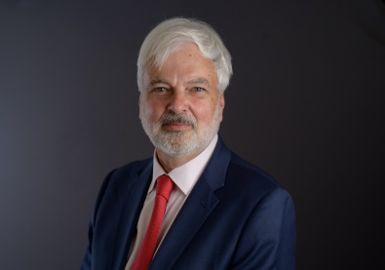
Richard has been Chief Executive of LCCI since February 2020.
LCCI is London’s key hub for the business community; it supports members’ businesses through a range of services, advocates on behalf of London’s business community in the most important forums of policy debate, and promotes ‘Global London’ as the best city in the world to do business – whether that’s to trade, invest, learn or find new commercial partners.
The business breakfast has been sponsored by the Cheapside Business Alliance. There is no charge for attending the event.
If you are able to attend this event, please complete the form below and return it to annekeates@gmail.com who will send you a confirmation of your booking. It would be helpful if you could respond by 22 February to enable us to finalise the catering arrangements.
Patricia Edmunds
President
The Ward of Cheap Club
Name:
Company:
Member of Ward of Cheap Club: yes/no
e-mail address:

